Task 1: Statistical Summary for Survey Data

- Scenario:
You are a data analyst intern working with survey responses stored as numerical lists.

- Task:
Use Google Gemini in Colab to generate a Python function that reads a list of numbers and calculates the mean, minimum, and maximum values.

- Expected Output:
  - Correct Python function
  - Output shown in Colab
  - Screenshot of Gemini prompt and result
PROMPT: Generate a Python function that takes a list of numerical survey responses and calculates the mean, minimum, and maximum values. Also provide an example input list and display the results.
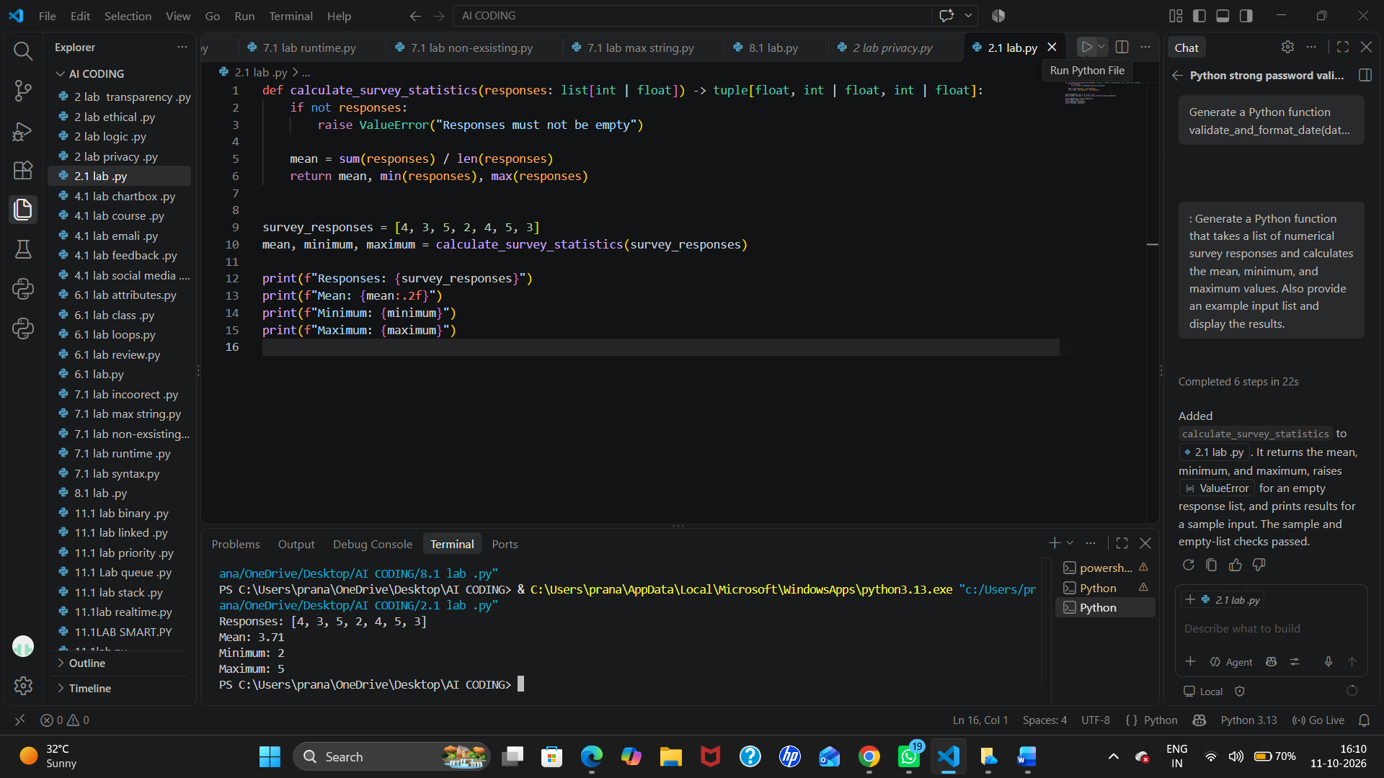

Task 2: Armstrong Number – AI Comparison

- Scenario:
You are evaluating AI tools for numeric validation logic.

- Task:
Generate an Armstrong number checker using Gemini and GitHub Copilot.
Compare their outputs, logic style, and clarity.

- Expected Output:
  - Side-by-side comparison table
  - Screenshots of prompts and generated code
PROMPT: Write a simple Python program to check whether a given number is an Armstrong number. Explain the logic briefly and include sample output.
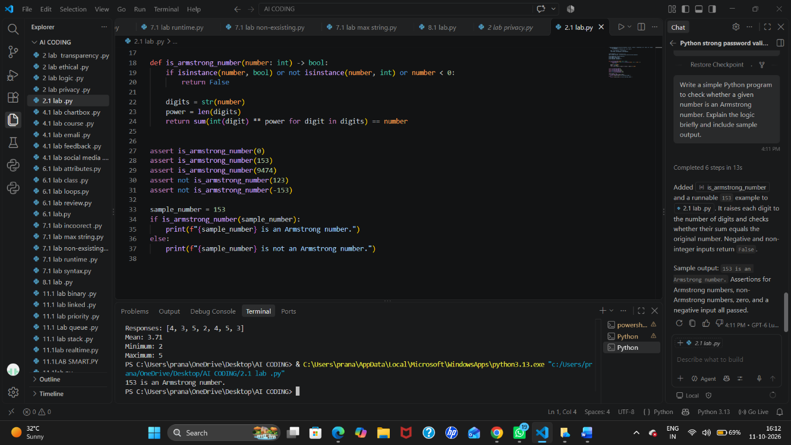

Task 3: Leap Year Validation Using Cursor AI

- Scenario:
You are validating a calendar module for a backend system.

- Task:
Use Cursor AI to generate a Python program that checks whether a given year is a leap year.
Use at least two different prompts and observe changes in code.

- Expected Output:
  - Two versions of code
  - Sample inputs/outputs
Brief comparison
PROMPT: Write a simple Python program that takes a year as input and checks whether it is a leap year. Use if-else statements and display the result.
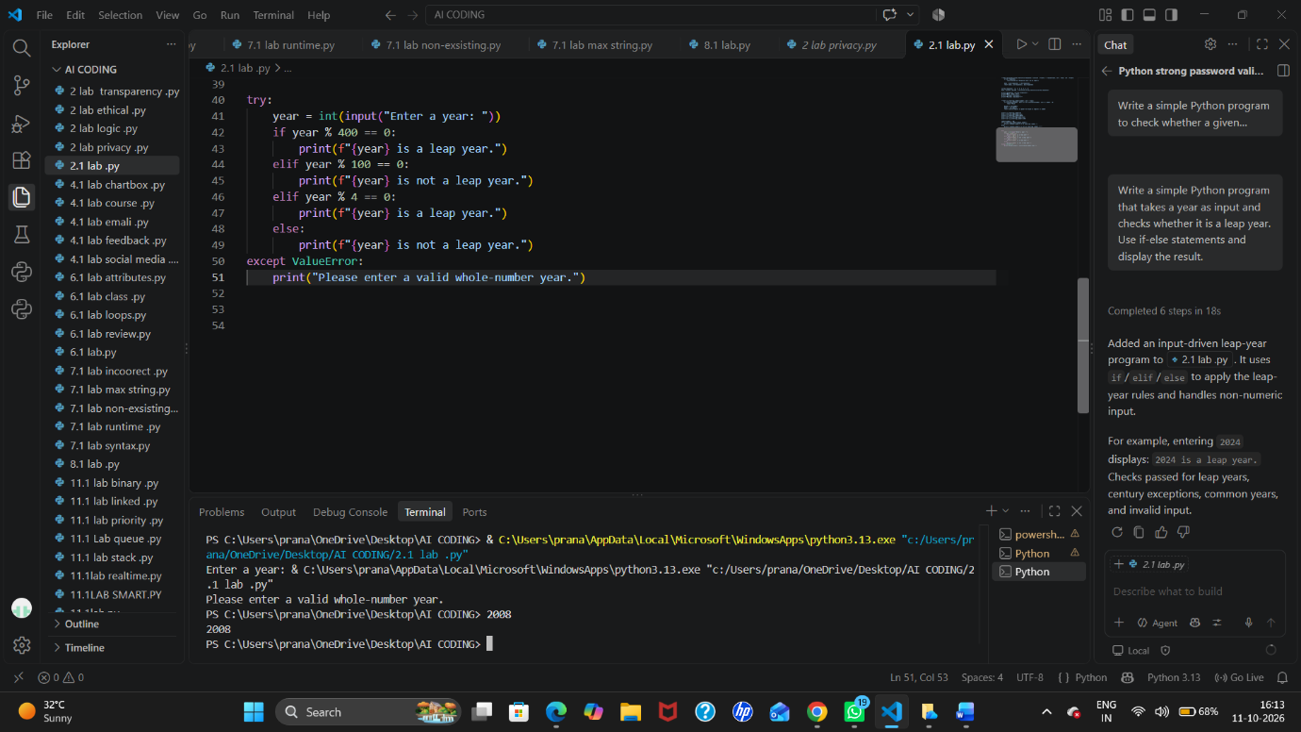

Task 4: Student Logic + AI Refactoring (Odd/Even Sum)

- Scenario:
Company policy requires developers to write logic before using AI.

- Task:
Write a Python program that calculates the sum of odd and even numbers in a tuple, then refactor it using any AI tool.

- Expected Output:
  - Original code
  - Refactored code
  - Explanation of improvements
PROMPT: Refactor a Python program that calculates the sum of odd and even numbers in a tuple. Make the code cleaner, shorter, readable, and reusable while keeping the same functionality and output.
